Barcode scanner

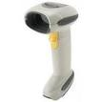

* **1) Model No-LS-4278(cordless scanner)**
* **Dimensions : 7.3 in. H x 3.85 in. L x 2.7 in. W**
* **Light Source : (Laser) 650nm laser diode**
* **Scan Element Frequency : 50Hz**
* **Decode Rate : 200 decodes per second**
* **Radio Range : Minimum 33 ft (10m) /**
* **Typical warehouse environment 50 ft. (15m)**



**2) Model No-LS-2208**

* **Dimensions : 6 in. L x 2.5 in. W x 3.34 in. D**
* **Light Source: 650 nm visible laser diode**
* **Scan Rate: 100 scans per second typical**
* **Working Distance: From contact to 17 in./ 43 cm**

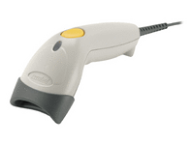

* **3) Model No-LS-1203**
* **Dimensions : 7.1 in. L x 2.4 in. W x 2.4 in. H**
* **Light Source: 650 nm visible laser diode**
* **Scan Rate: 100 scans per second typical**
* **Working Distance: From contact to 8 in./20.32 cm**