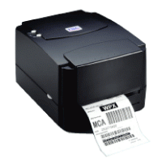

1) TSC TTP-244 Plus
- 4.09” Print width maximum
- 4” per second speed
- 203 dpi maximum
- 8 MB SDRAM, 4 MB Flash memory
- USB and RS232 interface
- 300 meter ribbon supply on a 1" core

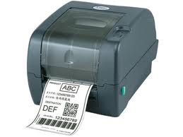

2) TSC TTP-247
- 4.25” Print width maximum
- 7” per second speed
- 203 dpi maximum
- 8 MB SDRAM, 4 MB Flash memory
- USB, Parallel and RS232 interface.
- 300 meter ribbon supply on a 1" core

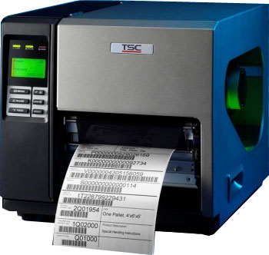

3) TSC TTP-268M
- 6.6” Print width maximum
- 8” per second speed
- 203 dpi maximum
- 32 MB DRAM, 8 MB Flash memory
- USB, Parallel and Serial interface.
- 450 meter ribbon supply on a 1" core
- LCD Display
- Industrial Printer

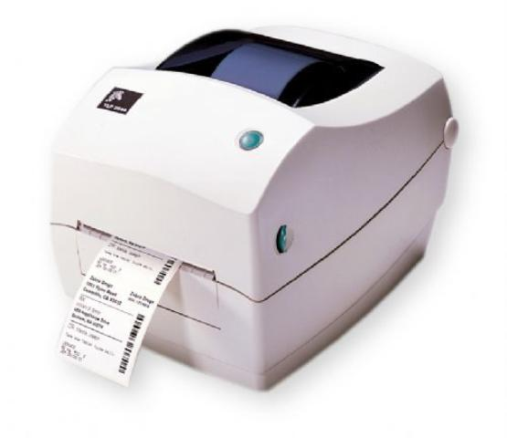

4) Zebra Tlp-2844 Barcode Printer
- 4.09” Print width maximum
- 3.5” per second speed
- Resolution 203 dpi
- USB, Parallel and RS232
- Desktop Printer

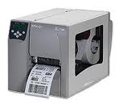

5) Zebra S4M Barcode Printer
- 4.09” Print width maximum
- Print Speed: 203 dpi - 6 inches / 300 dpi - 6 inches per sec
- Print Length: 203 dpi - 157 inches , 300 dpi - 73 inches
- Resolution 203 dpi and 300 dpi
- 8 MB SDRAM, 4 MB Flash memory
- USB and Parallel and serial
- Industrial Printer

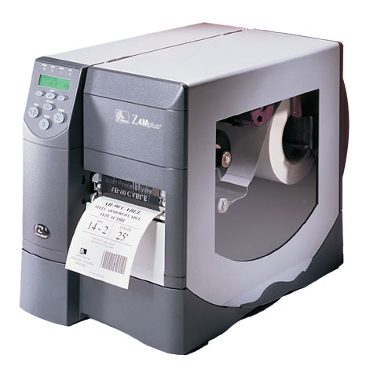

6) Zebra Z4M Plus Barcode Printer
- 4.09” Print width maximum
- Print Speed: 10 inches per sec
- Print Length: 203 dpi - 157 inches
- Resolution 203 dpi
- 8 MB SDRAM, 4 MB Flash memory
- USB and Parallel and serial
- Industrial Printer

